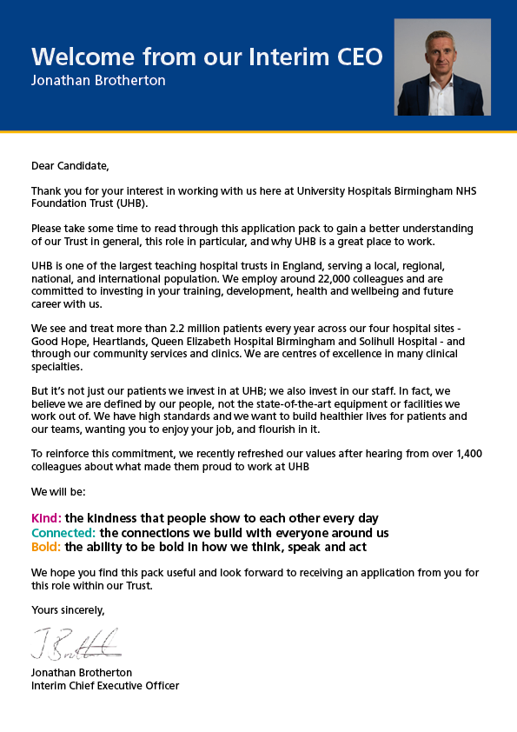
JOB DESCRIPTION

Job Title | Clinical Nurse Specialist
Pay Band | Band 6
Department | Urology
Division | 4
Reports to | Andrea Gianfagna
Professionally Responsible to | Chief Nursing Officer
JOB SUMMARY
Develop individual competence and knowledge which will support the provision and evaluation of seamless specialist nursing services, ensuring patients receive the highest standards of clinical care. You will develop specialist knowledge and skills, demonstrated through the provision of advice /education and support to staff, patients, families and carers. You will be supported by a more experienced nurse or nurses to enable you to achieve competence in agreed areas of specialist practice through exposure, training and education.

Responsible for on-going development and training of the policies, procedures, protocols and guidelines. You are accountable for safe, effective clinical practice working as part of a defined team, supporting team performance, ensuring efficient and effective use of physical and human resources, and will also provide / deliver a range of educational and training packages to health care staff and patients.

Based within a site or service or may be community based and work in a range of practice settings across health and care providers. Additionally, you may be required to practice in premises/ settings outside of NHS care providers as part of their role and travel to and from a range of practice settings across an agreed locality this may include secure units / prisons and other regulated settings where patients may reside.

TEAM/DEPARTMENT STRUCTURE CHART
Please update

KEY SKILLS
- Professional accountability for the maintenance of standards and professional practice as set by Trust Policies/Procedures, the NMC Code and Behaviour and relevant professional guidelines
- Provide specialist nursing advice to patients referred for specialist intervention, care and support within the services, being a point of contact for assessment, information and advice for the patient, family and carers
- In liaison with others support the development of staff caring for patients through support, formal education, practice development and role modelling
- To teach and act as a facilitator and supervisor to other staff
- As a Specialist Nurse you will practice under the direction of the Clinical Nurse Specialist Team / Service Leader
- In conjunction with other relevant clinical staff, you will assist with clinical development in maintaining and improving all aspects of clinical governance
- Use a range of techniques to ensure and monitor standards of clinical practice, audit, research and teaching to continually improve standards of care and patient experience
- Ensure safe and effective clinical practice
- Enhance patient experience
- Ensure effective delivery of organisational objectives
KEY RESPONSIBILITIES
- Provide treatment/advice as per speciality and scope of practice. This may be face to face, virtual or telephone, and incorporate the use of agreed protocols, clinical and professional guidelines, within an acute secondary healthcare facility or in a primary/community or home care setting
- Carry out specialist clinical practice within a designated group of patients as part of a multidisciplinary team. Ensure that high quality, current evidence-based nursing care underpins all actions with patients and is aligned to professional values of care, compassion and respect
- Accountable for administration and custody of medicines according to the Trust Policy, including safe administration of medicines, controlled drugs, intravenous drugs, transfusion of blood and blood products
- Provide a seamless, high-quality service from referral through to assessment, diagnosis, treatment and review, referring to other specialists as required
- Demonstrate safe, appropriate practice and specialist nursing advice using up to date knowledge and evidence. Make person centred, evidence-based judgements in partnership with others involved in the care process ensuring high quality care
- Continuously assess communication, educational and information needs for patients and their families, devise plans to ensure needs are met, ensure instructions/information are understood
- Use professional judgment to act as advocate for patients, support and enable patients and carers to make informed decisions
- Recognise and act to avoid situations that may be detrimental to the health and wellbeing of patients
- Work towards safe, timely discharge/transfer of care of patients from or between hospital and services
- Report and raise concerns about Safeguarding, accessing advice and support at the point of need
- Supervise, carry out and assist with clinical procedures/practice as required, ensuring optimal recovery to health of the patient
- Ensure effective handover of patients between health care professionals using a range of communication aids
- Facilitate high-quality cost-effective specialist service through monitoring/audit and other quality initiatives

BUDGETARY AND RESOURCE MANAGEMENT
- Participate in the appraisal process, where required undertake appraisal of others and actions to support revalidation
- Establish and maintain robust communications process within and external to your team
- Work cooperatively in partnership with others in planning, reviewing and developing the service/ward, promoting the involvement of patients/public
- Participate and contribute to innovation, service redesign or review where required, ensure these are linked to organisational priorities and support improved patient clinical and experience outcomes
- Seek opportunities for personal and team development
MANAGEMENT , SUPERVISORY, TEACHING, TRAINING RESPONSIBILITIES
- Act as a specialist educational resource for clinical staff, patients, carers and relevant external agencies by providing formal and informal education
- Support the development, updating, coordination and delivery of training programmes and seminars. Ensure the departments can access appropriate teaching, support and guidance, in accordance with the clinical area/departmental needs to agreed levels of skill and competence
- Participate in education and practice development on a Trust wide basis and as required at national and international level by attending, presenting at, and/or assisting with the coordination of study days, seminars, forums and conferences
- Ensure staff are fully trained on the range of equipment, consumable products associated with the care and treatment of patients and that they are educated to understand the correct method of clinical assessment before using such items with patients
RESEARCH AND DEVELOPMENT
- Utilise research findings in the delivery of specialist patient care, developing new ways of working to disseminate relevant information to staff
- Be aware of research/trials being undertaken within specialist field and assist with clinical trials and research
- Provide and accept constructive feedback and use this to reflect on your own practice
- Recognise signs of stress and the emotional impact of care in in self and others and take appropriate action, escalating to line manager as required
- Act with personal integrity within professional, ethical and legal frameworks and process to maintain and improve standards of care and practice
- Maintain professional records for personal and professional updating to support revalidation
- Act as a positive role model at all times in promoting the personal growth of self, peers and junior colleagues
- Utilise opportunities to support on-going professional development by undertaking delegated tasks for your line manager

EFFORT
- Take an active role in risk assessment, supporting the implementation of strategies to minimise risks. Ensuring incidents and near misses are reported and managed as per Trust Policy
- Work independently, organise own workload, manage own caseload and practice, identifying and maintaining supportive networks for self and others
- Participate in and facilitate service/departmental projects, audits, quality initiatives and statutory accreditation processes
- Maintain a safe, clean environment. Ensure hazards are reported as per Trust procedures and any equipment in use is in good working order and report appropriately when defective
- Ensure through good practice that patient experience initiatives are supported. Address any immediate concerns or complaints as they arise and escalate as required
TRUST VISION & VALUES
DO NOT AMEND THIS SECTION
The Trust is clear on its vision and values and aims to make sure that they are reflected in all areas of activity. Our vision is simple; building healthier lives. Our values apply to every member of staff and help us in all we do and how we do it. They are:

Kind: The kindness that people show to each other every day
Connected: The connections we build with everyone around us
Bold: The ability to be bold in how we think, speak and act
ADDITIONAL INFORMATION
This job description is designed to assist post holders with understanding what is expected of them in their role. University Hospitals Birmingham NHS Foundation Trust may ask them to undertake other duties, as required, which are not necessarily specified on the job description but which are commensurate with the grade of the post.

The job description itself may be amended from time to time in consultation with the post holder, within the scope and general level of responsibility attached to the post.

All post holders must take responsibility to ensure that they are aware of and adhere to all Trust policies, procedures and guidelines relating to their employment regardless of their position within the Trust.

Last Updated: ………………………………………………………….

PERSON SPECIFICATION
JOB TITLE:
TRAINING, QUALIFICATIONS AND PROFESSIONAL REGISTRATIONS
ESSENTIAL | DESIRABLE
- Registered Nurse with valid NMC registration
- Evidence of post registration CPD / post registration qualification in appropriate area of speciality or professional knowledge supplemented by specialist experience and short courses to FHEQ Level 6
EXPERIENCE & KNOWLEDGE
ESSENTIAL | DESIRABLE
- Evidence and ability to revalidate as required by the NMC  - Significant post registration experience, with evidence of passion/ enthusiasm and knowledge for the associated area of specialist practice  - Evidence of achievements and career development in current post and of on-going professional development/ competence  - Demonstrate specialist knowledge underpinned by theory and CPD relevant to speciality  - Experience and enthusiasm for teaching/assessing and supervising others in a clinical setting  - Experience of working in a multi-disciplinary and cross agency work environment  - Demonstrate understanding / experience / willingness to be a practice-based supervisor / assessor as detailed in the NMC | - Experience in service development
SKILLS & ABILITY
ESSENTIAL | DESIRABLE
- Ability to explain the requirement to balance clinical caseload and developing skills, knowledge and competence
- Willingness to achieve competence in a range of clinical skills and expanded practices
- Knowledge of corporate and clinical governance
- Ability to adapt behaviour to changing circumstances
- Ability to work a varied shift pattern where required and ability to work across UHB sites or off site in NHS premises where required
- Car Driver
OTHER SPECIFIC REQUIREMENT
ESSENTIAL | DESIRABLE

