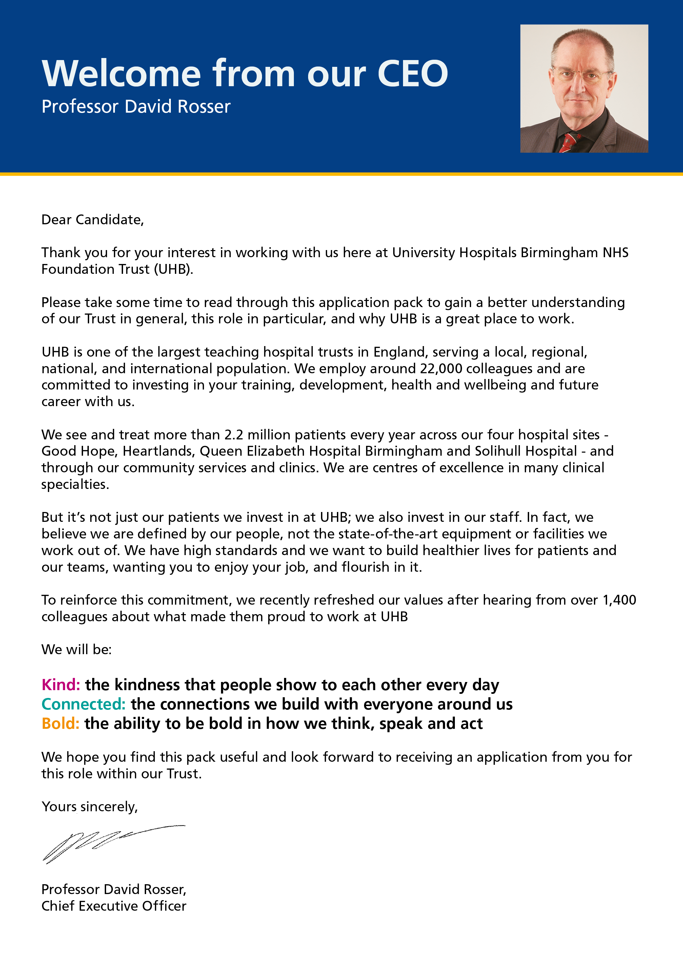

JOB DESCRIPTION

Job Title | Medical Secretary
Pay Band | 3
Department | Ophthalmology
Division | 4
Reports to | Medical Secretary - Supervisor
Professionally Responsible to | TBC at time of appointment
JOB SUMMARY
To provide secretarial support to Consultants and their teams with particular responsibility for audio typing clinic letters, discharge summaries, general copy typing correspondence, minutes and reports. To provide administrative support to the department/Clinical Team.
The post holder will provide an empathic and sensitive point of contact for patients/relatives and carers, undertaking work under the direction of the Medical Secretary Supervisor.

TEAM/DEPARTMENT STRUCTURE CHART
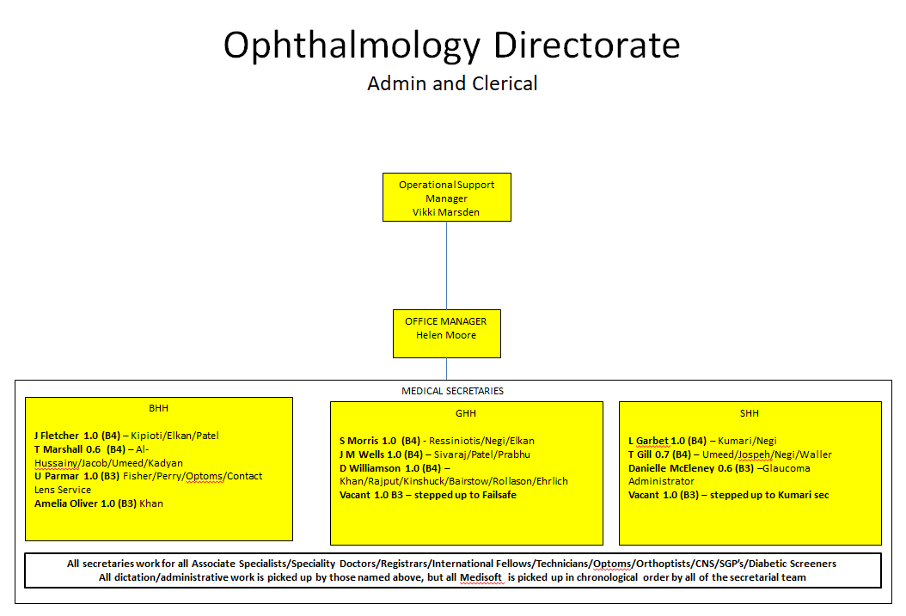

KEY SKILLS
- Liaise with staff and service users
- Provide excellent telephone skills. Accurately record telephone messages and other enquiries and refer as appropriate
- To provide a point of contact for patients/relatives/carers, GPs and other health care professionals who can be emotional and highly distressed, ensuring that any language or other communication barriers are overcome
- Provide effective communication and problem solving both face to face and via telephone
- Be sympathetic and sensitive to the requirements of staff, service users when communicating by telephone or face to face, including dealing with a difficult situation, e.g. aggressive or demanding behaviour
- Attend admin team / departmental meetings on a regular basis. Contribute to building effective teamwork in exchanging views, ideas and communicating effectively

KEY RESPONSIBILITIES
To touch type from audio and/or copy type from written documentation the following documents: clinic letters; results letters; discharge summaries; medical reports and reports in response to complaints. This requires an understanding of medical terminology, phraseology, and medications. Some documents may be of a complex or distressing nature

- Arranging patients’ appointments as required under direction of the Medical Secretary Supervisor
- Arranging for patients to be seen for theatre/day case admissions when required and directed by the Medical Secretary Supervisor
- To exercise initiative and judgement based on acquired knowledge and experience when dealing with enquiries of a clinical and non-clinical nature
- Ensure that clinic letters and discharge summaries are sent out in accordance with the locally agreed time limits
- Receiving and dealing with telephone enquiries as appropriate
- To maintain the Consultant’s diaries as required
- Input and look up patient data on Trust IT systems in accordance with Trust policy
- To ensure Consultant’s post is opened daily and dealt with accordingly
- Arrange meetings and appointments as necessary
- To assist colleagues as directed by the Medical Secretary Supervisor in times of pressure of work
- Obtaining & receiving hospital notes from Medical records Department as required using the case note tracking system
- Co-operate in the introduction of new technology and new working practices to ensure the smooth running of the department
- Photocopying, scanning letters and documents as required

Analytical and Judgemental Skills / Freedom to Act
- Ability to make decisions and take actions within the team relating to routine enquiries, whilst receiving support and supervision
- Ability to recognise situations that should be referred onto the Supervisor and take prompt and appropriate action
- Receive and open incoming post and take action as required

Planning and Organisational Skills
- To manage and progress results of patient investigations and on receipt, prioritise and action according to clinical need, with guidance from the medical team
- Organise own day-to-day work tasks showing an ability to prioritise in order to achieve set timescales
- Undertake work that has been prioritised by the Supervisor/ Line Manager
- Book and monitor room bookings
- Arrange meetings as and when required

Policy and Service Responsibilities
- Work collaboratively as part of an integrated team
- Work within and keep up to date with National and Trust legislation, guidelines, policies, procedures, protocols and code of conduct relating to own role
- Participate in and contribute to the effective introduction of new systems and initiatives leading to the improvement and development of patient services
Responsibility for Information
- To liaise with medical records with regard to availability of medical notes for
- forthcoming clinics, ensuring where possible, all results/correspondence is available for the patient’s clinic appointment
- To develop and maintain an efficient individual filing system on behalf of the team to include correspondence, reports, complaints, research and results
- Be responsible for confidentiality in line with Trust policy and procedures
- Accurately input data using a variety of Trust IT systems in a timely way Strictly adhere to Caldicott and the Data Protection Act
- Prepare and scan information onto the Trust IT systems
- Ensure all information held is kept up to date
- Be responsible for the quality of information. Photocopy and distribute documents as required
- Shred and destroy confidential documentation in line with Trust policy
- Provide information / produce basic routine reports at an appropriate level under supervision
- Input staff information into the Electronic Staff Record (ESR) adhering to confidentiality and only accessing the information required to fulfil the role / task
- Provide reciprocal cover for secretarial team during annual leave and sickness absence.
Medical secretaries will be responsible for ensuring that Consultants receive patient results as they are reported, communicating the results to GPs/patients efficiently and undertaking any actions required as outlined in the dictated letter, i.e., request an outpatient appointment, ensure patients are put on the waiting list, update the open clocks “sent for test” database when patients have been discharged back to their General Practitioners care (admin events and patient appointments can also be requested via this database). The medical secretary should actively manage the open clocks “sent for test” database, chasing patient results and expediting the patient pathway where any delays become evident. The medical secretary should understand the RTT 18 week pathway and make every effort to ensure patients receive appointments, diagnostic or surgical admissions within 18 weeks; a similar process should be in place to support effective communication of results within the RTT timeline. Medical secretaries will ensure they meet the 10 day turnaround target when communicating outpatient, diagnostic, elective and general letters to General Practitioners and patients. If this is not achieved early escalation to the General Management team must take place, given the direct impact this could have on the RTT position when communicating results to GPs/patients.

BUDGETARY AND RESOURCE MANAGEMENT
- Have a personal duty of care for all equipment and resources used
- Maintain stock control of stationery / clinical supplies
- Responsibility for Staff
- Participate in the induction and training of all new members of staff
- Demonstrate own activities to new / less experienced staff
MANAGEMENT , SUPERVISORY, TEACHING, TRAINING RESPONSIBILITIES
RESEARCH AND DEVELOPMENT
- Undertake surveys and routine audits of own work as and when required

EFFORT
TRUST VISION & VALUES
DO NOT AMEND THIS SECTION
The Trust is clear on its vision and values and aims to make sure that they are reflected in all areas of activity. Our vision is simple; building healthier lives. Our values apply to every member of staff and help us in all we do and how we do it. They are:

Kind: The kindness that people show to each other every day
Connected: The connections we build with everyone around us
Bold: The ability to be bold in how we think, speak and act
ADDITIONAL INFORMATION
This job description is designed to assist post holders with understanding what is expected of them in their role. University Hospitals Birmingham NHS Foundation Trust may ask them to undertake other duties, as required, which are not necessarily specified on the job description but which are commensurate with the grade of the post.

The job description itself may be amended from time to time in consultation with the post holder, within the scope and general level of responsibility attached to the post.

All post holders must take responsibility to ensure that they are aware of and adhere to all Trust policies, procedures and guidelines relating to their employment regardless of their position within the Trust.

Last Updated: ………………………………………………………….

PERSON SPECIFICATION
JOB TITLE:
TRAINING, QUALIFICATIONS AND PROFESSIONAL REGISTRATIONS
ESSENTIAL | DESIRABLE
- Good General Education (e.g. GCSE English and Maths A-C) GCSE Level 9-4  - Business Administration NVQ level 3 or equivalent experience in a clerical environment | - AMSPAR Certificate/equivalent qualification or equivalent knowledge of medical terminology
EXPERIENCE & KNOWLEDGE
ESSENTIAL | DESIRABLE
- Experience of dealing with the Public/Customer service experience  - Experience of working with a range of Microsoft Office packages (eg. Word, Excel and Outlook)  - Experience of using IT systems | - Experience of working in a busy environment  - Experience of working in Healthcare
SKILLS & ABILITY
ESSENTIAL | DESIRABLE
- Good communication / customer care skills both written and verbal demonstrating sympathy and compassion
- Good keyboard / IT skills
- Good organisation skills and ability to multitask
- Good time management skills
- Ability to deal professionally with enquiries from staff
- Ability to problem solve
- Understand confidentiality and apply the principles
- Ability to pay attention to detail where there are predictable interruptions to the work pattern
- Ability to deal with stressful situations and sensitive

OTHER SPECIFIC REQUIREMENT
ESSENTIAL | DESIRABLE
- Work effectively and flexibly as part of a team to meet the needs of the services  - Confident in dealing with people at all levels  - Must be able to demonstrate an understanding of equality and diversity  - Mature open and flexible approach to work  - Demonstrates care and compassion  - Good inter-personal and communication skills.  - Good organisational skills  - Team Player  - Conscientious  - Demonstrates reliability, motivation and commitment  - Ability to travel to multiple sites | - Ability to work under pressure and deal with stressful situations

