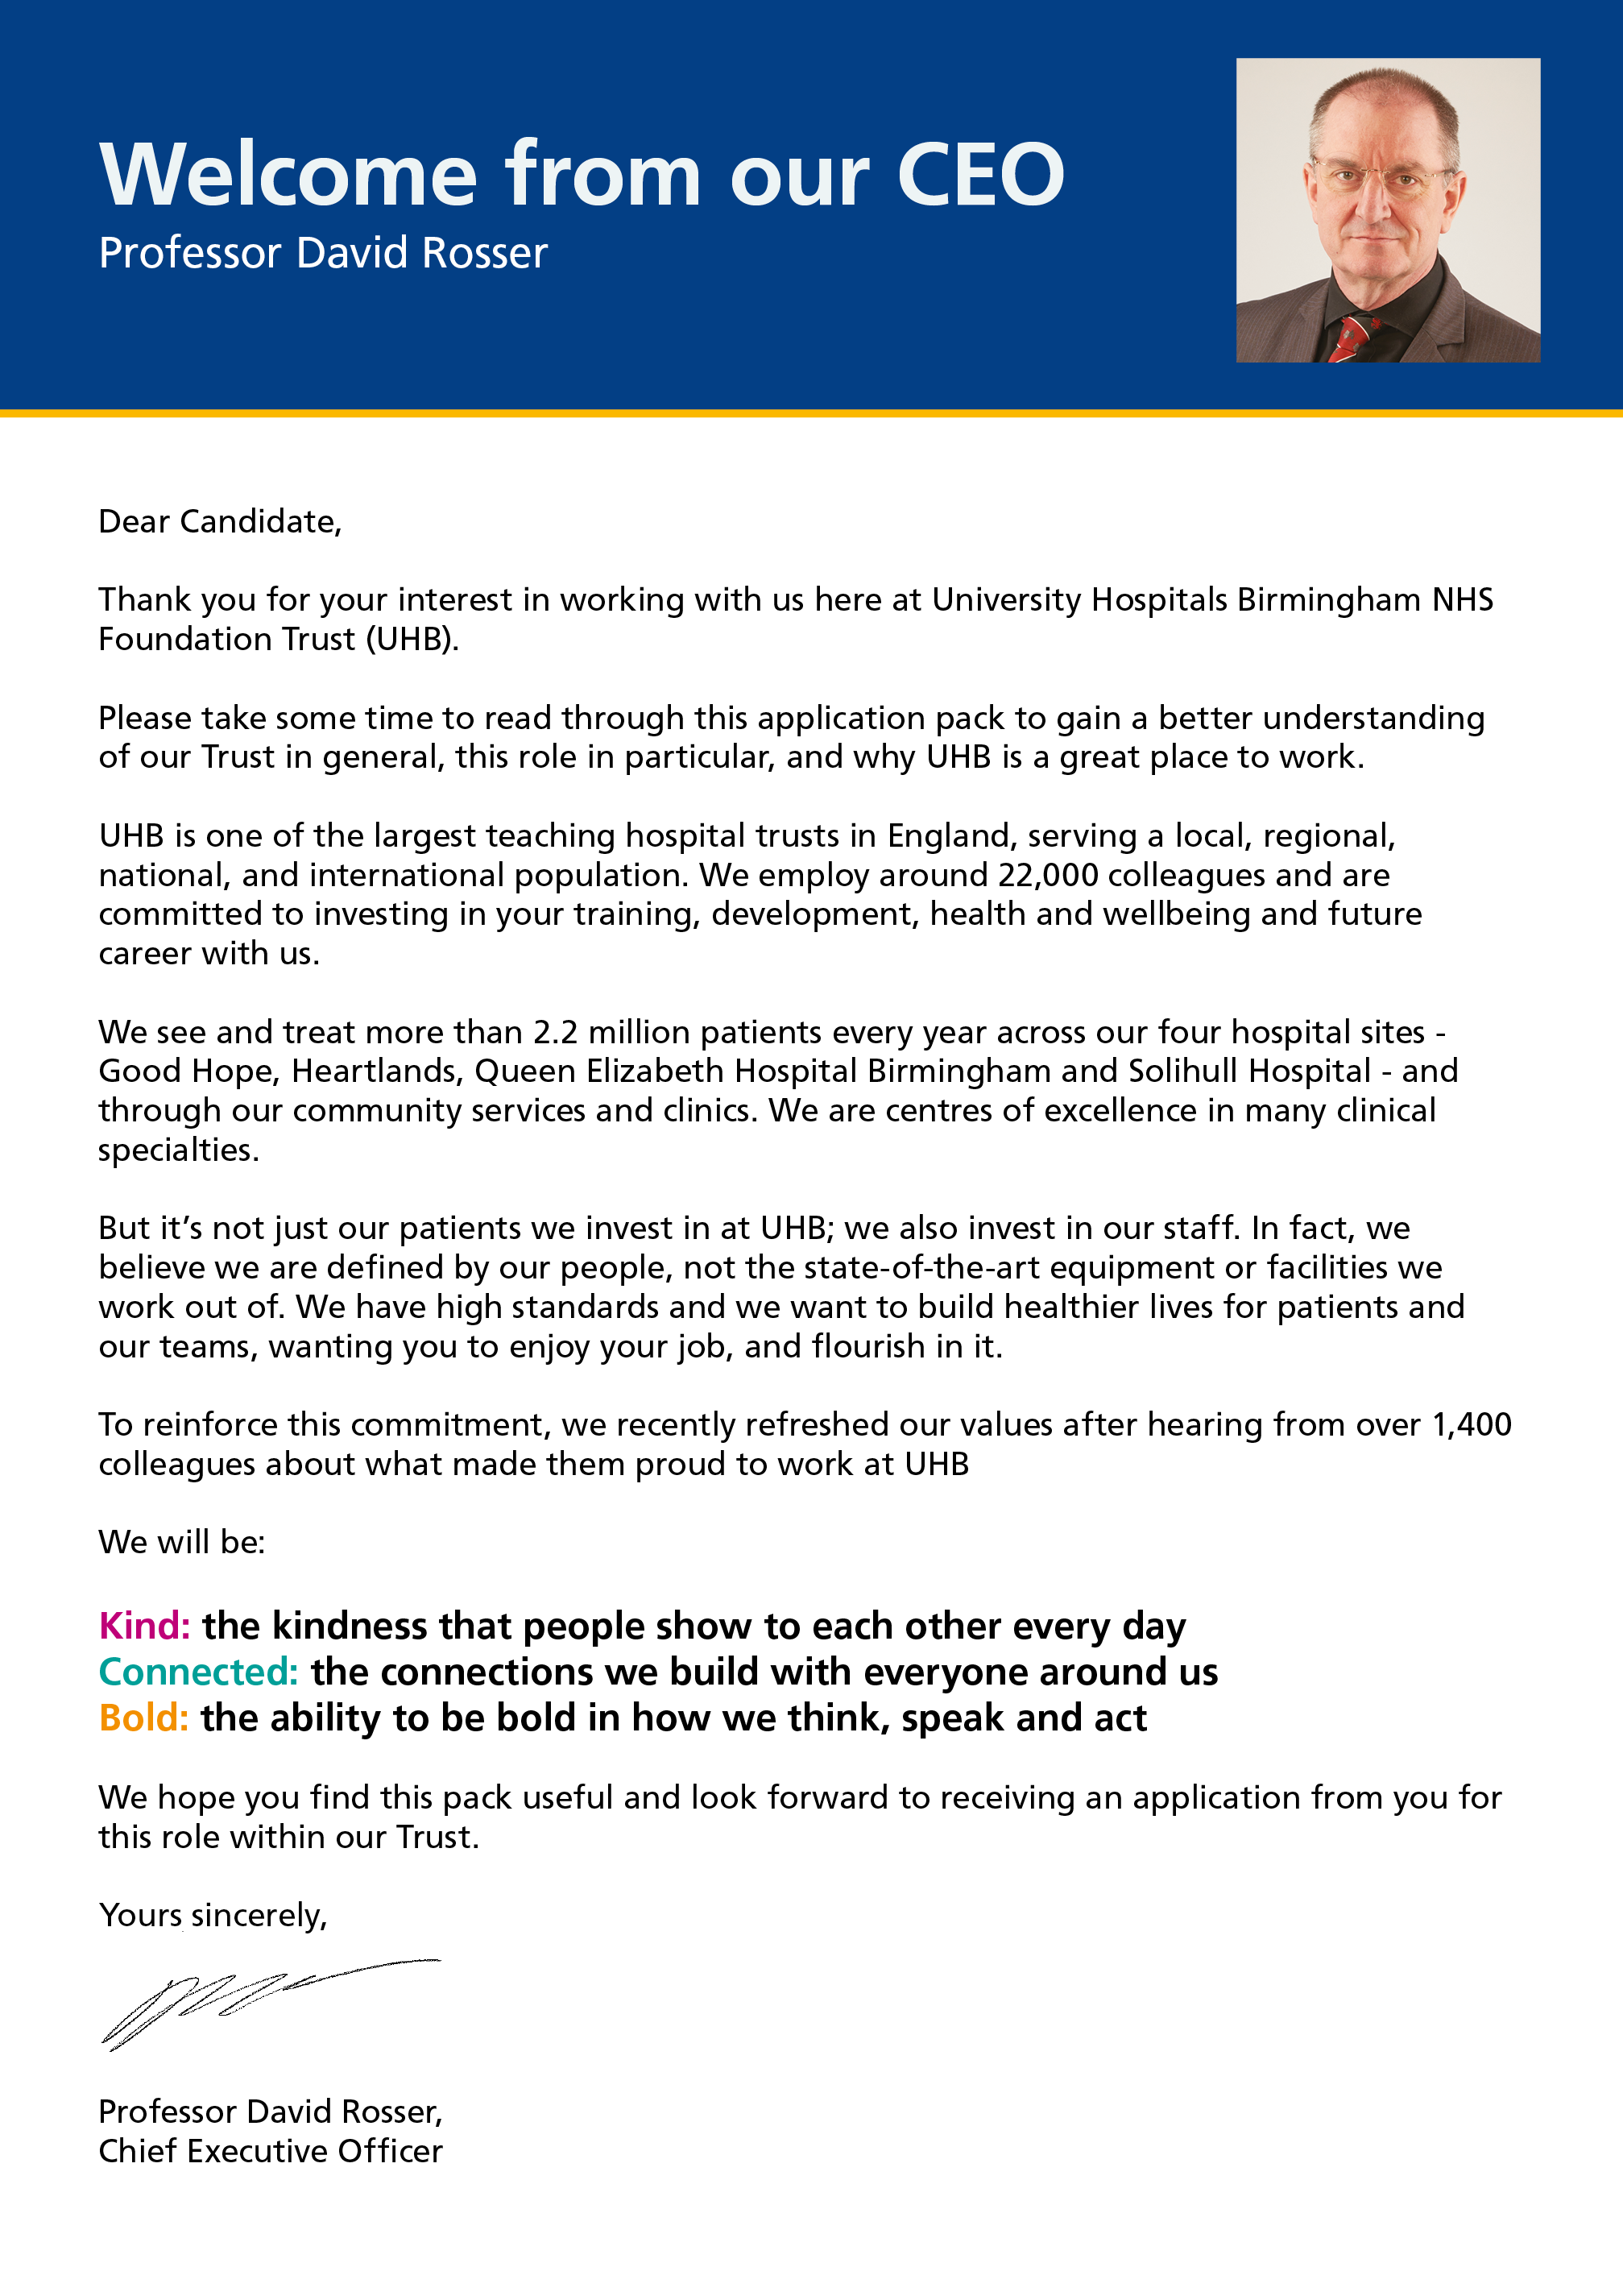

JOB DESCRIPTION

Job Title | Ward Clerk Team Leader
Pay Band | 4
Department | Patient Administration
Division | Corporate
Reports to | Supervisor/Manager
Professionally Responsible to
JOB SUMMARY
To operationally line manage a group of Ward Clerks ensuring compliance with Trust standards of Data Quality. To train new members of staff and locate staff as and when required.

TEAM/DEPARTMENT STRUCTURE CHART
KEY SKILLS
- To advise, support and line manage a team of ward clerks on a daily basis ensuring adequate coverage of duties across a defined group of wards.

- To highlight any staffing issues/concerns to the Ward Clerk Support Manager/Ward Clerk Manager.

- To monitor the timeliness and quality of the teams data entry in line with metrics set out by the Ward Clerk Manager by undertaking regular performance checks.

- To undertake regular audits of service user data to comply with National Guidelines including IGT Data Quality Standards

- To implement Trust policies e.g. H&S and informal stages of HR policies of the Sickness Attendance Management, Disciplinary and Grievance.

- To perform yearly appraisals for each team member in line with Trust Policy, including six monthly reviews.

- Reviewing policies and procedures, proposing changes to improve working practices and standards.

- Take a lead responsibility in ensuring the case note tracking system for the booking in and out of patient’s notes is fully adhered to on the ward.

- To coordinate and carry out ‘on the job’ training and instruction of eg. Locate agency staff / new ward clerks in the correct use of PAS and other inpatient administrative functions.

KEY RESPONSIBILITIES
- Ensure that up–to-date patient information is maintained on the Patient Administration System.

- Ensure all patient information is, e.g. Results and correspondence is filed promptly and correctly in patient notes and is available for clinical coding.

- To take incoming telephone calls and e-mails ensuring they are dealt with efficiently and effectively at all times. Ensure accurate message taking and channel information/requests to appropriate members of the multidisciplinary team.

- To ensure the accurate and timely update of the PAS system, admission diaries to include accurate admissions, transfers, discharges to and from the ward and any changes to patient details.

- Print patient labels, KMR1 forms and wristbands for new and existing patients, ensuring all old labels are discarded appropriately to prevent a clinical risk.

- Book outpatient appointments as appropriate for patients leaving hospital; offering patients a choice of dates.

- To be familiar with the Trust’s Control of Infection policy and actively encourage good practice on the ward.

- To identify Overseas and Private patients and implement next steps, as agreed with line manager, in accordance with Trust Policy.

- Ensure the ward reception desk / nurse base are clean and tidy and meet required H&S standards, including the update of notice boards.

- Take responsibility for the collection and disposal for confidential waste.

- Undertake general admin support duties for the ward: photocopying, distributing post, and laminating.

- To report patient deaths to relevant GPs, updating PAS and liaising with Bereavement Services eg deceased’s belongings.

BUDGETARY AND RESOURCE MANAGEMENT
- To maintain a reliable and cost effective stationery supply for the ward.

MANAGEMENT , SUPERVISORY, TEACHING, TRAINING RESPONSIBILITIES
- Participate in the induction and training of all new members of staff.
- Demonstrate own activities to new / less experienced staff.
• Organise own day-to-day work tasks showing an ability to prioritise in order to achieve set timescales.
- Undertake work that has been prioritised by the Senior Sister/Ward Manager.
- Arrange meetings as and when required.

RESEARCH AND DEVELOPMENT
- Undertake surveys and routine audits of own work as and when required

EFFORT
TRUST VISION & VALUES
DO NOT AMEND THIS SECTION
The Trust is clear on its vision and values and aims to make sure that they are reflected in all areas of activity. Our vision is simple; building healthier lives. Our values apply to every member of staff and help us in all we do and how we do it. They are:

Kind: The kindness that people show to each other every day
Connected: The connections we build with everyone around us
Bold: The ability to be bold in how we think, speak and act
ADDITIONAL INFORMATION
This job description is designed to assist post holders with understanding what is expected of them in their role. University Hospitals Birmingham NHS Foundation Trust may ask them to undertake other duties, as required, which are not necessarily specified on the job description but which are commensurate with the grade of the post.

The job description itself may be amended from time to time in consultation with the post holder, within the scope and general level of responsibility attached to the post.

All post holders must take responsibility to ensure that they are aware of and adhere to all Trust policies, procedures and guidelines relating to their employment regardless of their position within the Trust.

Last Updated: ………………………………………………………….

PERSON SPECIFICATION
JOB TITLE: Ward Clerk Team Leader
TRAINING, QUALIFICATIONS AND PROFESSIONAL REGISTRATIONS
ESSENTIAL | DESIRABLE
- Pass in English Language GCSE or equivalent (E) | - NVQ level 3 Administration or equivalent commensurate experience (D)  - Advanced level Oceano Inpatient Modules (D)
EXPERIENCE & KNOWLEDGE
ESSENTIAL | DESIRABLE
- Relevant Senior Administrative experience (E)  - Keyboard skills, (E)  - Clerical organisational skills (E)  - Awareness of the need for confidentiality | - Extensive Oceano PAS system experience, (D)  - Experience of leading teams (D)  - Previous NHS experience (D)  - Knowledge of Microsoft systems
SKILLS & ABILITY
ESSENTIAL | DESIRABLE
- Demonstrates ability to line manage and motivate other staff.
- Excellent influencing and negotiating skills.
- Excellent reception skills / meeting greeting techniques.
- Excellent organisational / prioritisation skills
- Excellent face to face verbal communication e.g.
with potentially anxious and distressed patients and visitors.
- Professional telephone skills / manner.
- Demonstrable Negotiating Skills – ward team / other departments/ patients and relatives
- Good writing skills – message taking /document completion.
- Proficient in Microsoft Access, Excel & Word.
- Good general key board skills
- Ability to be impartial and maintain confidentiality
Ability to use initiative and utilise quiet times to maintain standards and initiate quality improvements to the service provided.
- Able to work effectively alone or as part of a team

OTHER SPECIFIC REQUIREMENT
ESSENTIAL | DESIRABLE
- Use of a computer screen for periods of time.  - Lifting / handling of patients notes  - This post can entail a significant amount of walking between Hospital sites, QEHB and Heritage Building | Commitment to the Trust’s Vision & Values  Calm under pressure  - Able to manage difficult and stressful situations  - Conscientious and hard working.  - Reliable  - Flexible  - Honest – may be a requirement to handle and secure financial donations.

