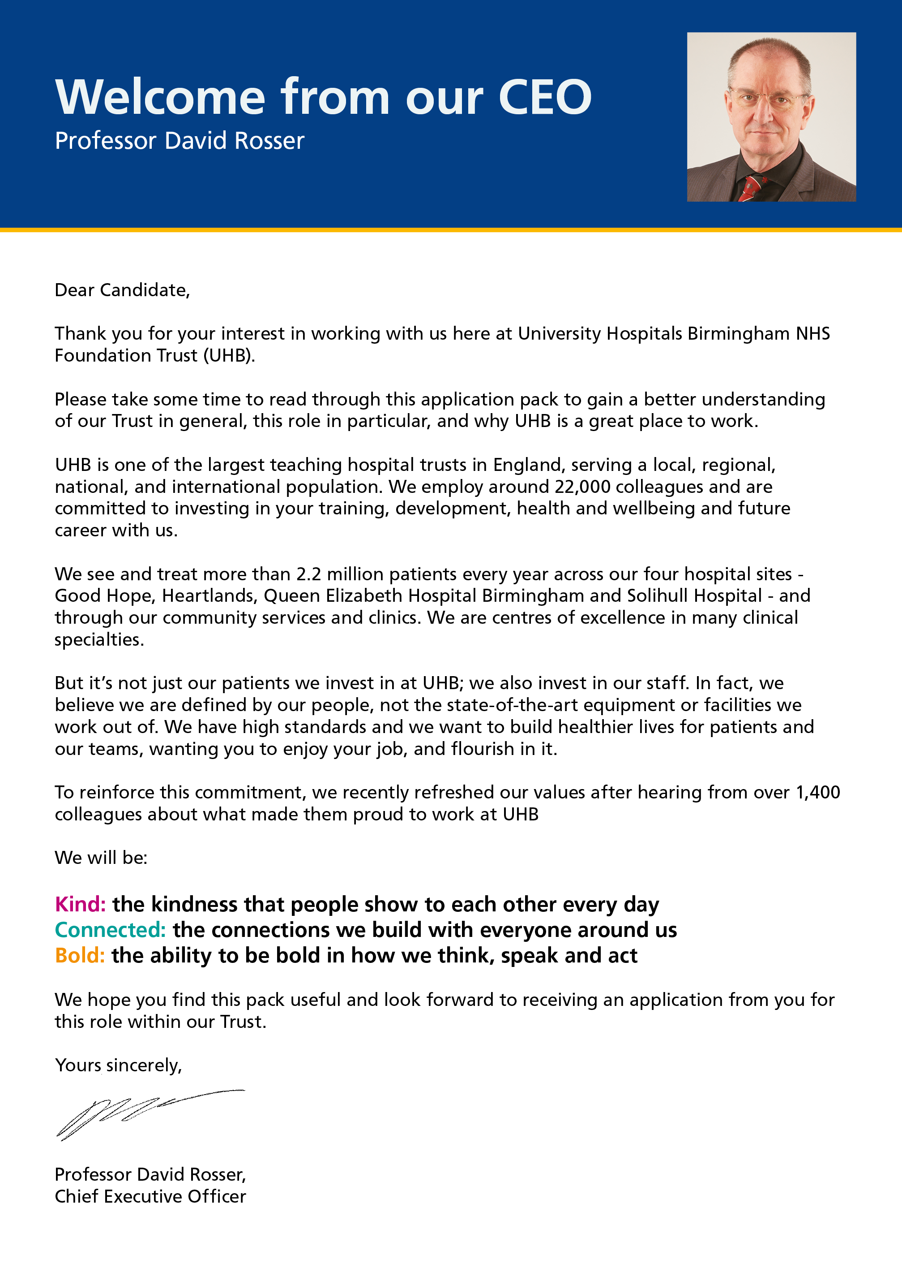

JOB DESCRIPTION

Job Title | Adult Congenital Heart Disease (ACHD) Database Manager
Pay Band | 3
Department | Cardiology
Division | 2
Reports to | Cardiology Team Leader
Professionally Responsible to | Cardiology General Manager
JOB SUMMARY
The post holder will be responsible for developing and maintaining robust processes for capturing, saving and analysing data relating to ACHD interventions and cardiac surgery. The post holder will work in those areas of Cardiology and Cardiac Surgery, as determined by the needs of the post. They will also be responsible for overseeing and performing statistical analyses on data derived from developed systems as well as producing reports. They will provide information analyses to be used by clinicians and business managers.

TEAM/DEPARTMENT STRUCTURE CHART
KEY SKILLS
- Liaise with staff, service users and external agencies
- To provide a point of contact for service users
- Liaise with medical and nursing staff and other multi-disciplinary teams regarding patient appointments/pathways
- Accurately record telephone messages and other enquiries and refer as appropriate
- Attend admin team/departmental meetings on a regular basis. Contribute to building effective teamwork in exchanging views, ideas and communicating effectively
- Maintain confidentiality at all times
- Accurately input and record clinical data onto a National database

KEY RESPONSIBILITIES
- To review the data requirements of the stakeholders within the context of specific nationally agreed datasets, and research data requirements
- Assist and support clinical staff in daily data collection
- Assist or develop initiatives to improve the process of audit data collection and presentation
- Help to develop symptoms to ensure comprehensive retrieval of relevant data
- To be responsible for the recording and electronic transmission to a number of national databases ensuring that data is submitted accurately and to set deadlines
- To co-ordinate ACHD MDT meetings and to action any patient outcomes as discussed at the meeting
- To take a lead role in the production of audit data and information for regional and departmental meetings
- To work as an integral member of the ACHD team and participate in all MDT meetings and record outcomes of such meetings
- Develop and maintain a communication system, both within the department and externally, that ensures effective dissemination of information in relation to the work that is conducted
- Maintain an up-to-date knowledge on clinical information, clinical outcomes, national data requirements and statistical analysis. To keep up-to-date with information practices and policies through all the appropriate resources, to enable effective delivery of the information service to the trust
- Identify personal training needs and ensure personal development of knowledge and skills
- To be responsible for ensuring data quality within the ACHD administrative team is of a high standard. To liaise with the management team flagging any potential problems. Take a lead in developing and running a system to monitor, audit and improve data collection and quality
- To ensure coding for all procedures is carried out. To be proactive in identifying potential income streams from procedures undertaken in clinical areas.
- Ensure confidentiality of all audit data
- Create documents/spreadsheets/reports as required using IT systems
- Use Trust systems to input electronic data as required
- Input and look up data on Trust IT systems in accordance with Trust policy
- Analyse and extract complex data sets from a number of different sources
- Arrange meetings as necessary
- To assist colleagues as directed by the Line Manager in times of pressures of work
- Photocopying and scanning of documents as required
- Review and action electronic correspondence and disseminate appropriately
- Organise own day-to-day tasks showing an ability to prioritise in order to achieve set timescales
- Work within and keep up to date with National and Trust legislation, guidelines, policies, procedures, protocols and code of conduct relating to own role
- Strictly adhere to the Caldicott guidelines and Data Protection Act

BUDGETARY AND RESOURCE MANAGEMENT
- Have a personal duty of care for all equipment and resources used
- Demonstrate own activities to new/less experienced staff

MANAGEMENT , SUPERVISORY, TEACHING, TRAINING RESPONSIBILITIES
RESEARCH AND DEVELOPMENT
- Undertake surveys and routine audits of own work as and when required

EFFORT
TRUST VISION & VALUES
DO NOT AMEND THIS SECTION
The Trust is clear on its vision and values and aims to make sure that they are reflected in all areas of activity. Our vision is simple; building healthier lives. Our values apply to every member of staff and help us in all we do and how we do it. They are:

Kind: The kindness that people show to each other every day
Connected: The connections we build with everyone around us
Bold: The ability to be bold in how we think, speak and act
ADDITIONAL INFORMATION
This job description is designed to assist post holders with understanding what is expected of them in their role. University Hospitals Birmingham NHS Foundation Trust may ask them to undertake other duties, as required, which are not necessarily specified on the job description but which are commensurate with the grade of the post.

The job description itself may be amended from time to time in consultation with the post holder, within the scope and general level of responsibility attached to the post.

All post holders must take responsibility to ensure that they are aware of and adhere to all Trust policies, procedures and guidelines relating to their employment regardless of their position within the Trust.

Last Updated: ………………………………………………………….

PERSON SPECIFICATION
JOB TITLE: ACHD Database Manager
TRAINING, QUALIFICATIONS AND PROFESSIONAL REGISTRATIONS
ESSENTIAL | DESIRABLE
- Good general education (e.g GCSE English and Maths (A-C/9-4)  - IT skills/qualifications | - Business Administration NVQ or equivalent experience in an administrative environment
EXPERIENCE & KNOWLEDGE
ESSENTIAL | DESIRABLE
- Experience of working with a range of Microsoft Office packages (Word/Outlook/Excel)  - Experience of using IT systems and database software  - Experience of data management and/or clinical audit and information systems comparable to a level 3 qualification | - Experience of working in a busy environment  - Experience of working in Healthcare
SKILLS & ABILITY
ESSENTIAL | DESIRABLE
- Good communication skills both written and verbal
- Good keyboard/IT skills
- Good organisation skills and ability to multitask
- Persuade and motivate clinical staff on the importance of accurate and timely data collection
- Understanding of data compliance
- Good time management skills
- Ability to deal professionally with enquiries from staff and external stakeholders
- Ability to problem solve
- Understand confidentiality and apply the principles in every day working practice
- Ability to pay attention to detail where there are predictable interruptions to the work pattern
- Ability to deal with stressful situations and sensitive issues
- Work effectively and flexibly as part of a team to meet the needs of the services
- Confident in dealing with people at all levels
- Must be able to demonstrate an understanding of equality and diversity
- Mature, open and flexible approach to work
- Demonstrate care and compassion
- Good interpersonal skills
- Team player
- Conscientious
- Demonstrates reliability, motivation and commitment

OTHER SPECIFIC REQUIREMENT
ESSENTIAL | DESIRABLE
 | - Ability to work under pressure and deal with stressful situations

